Latihan

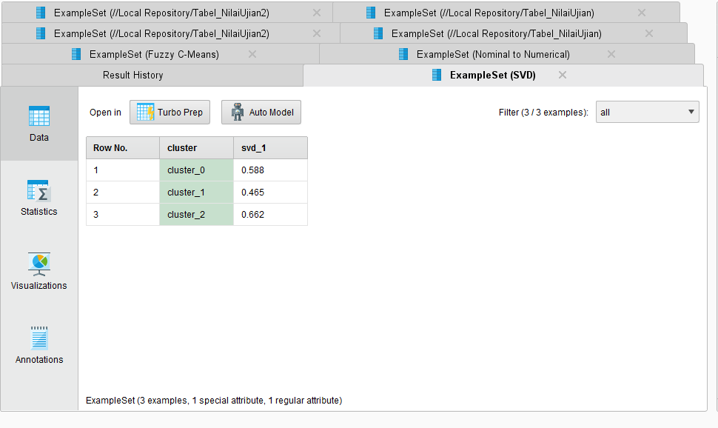

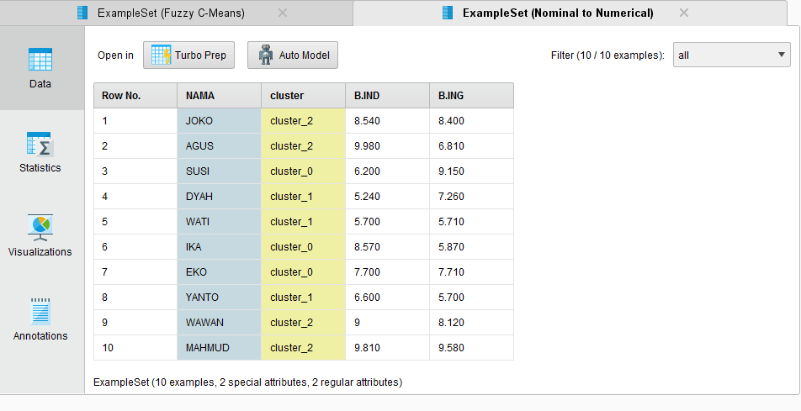

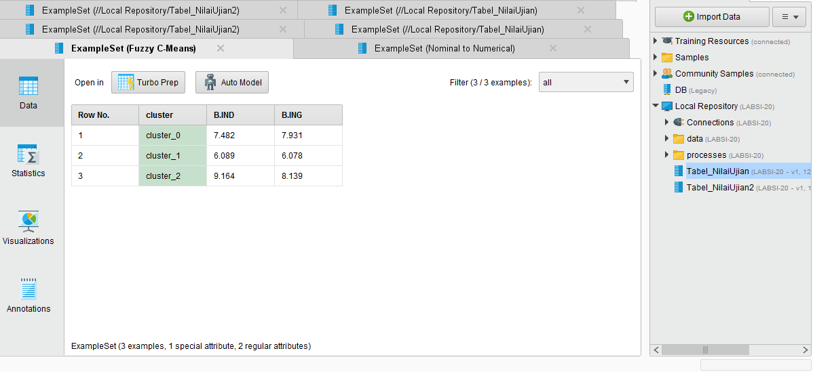

TUGAS

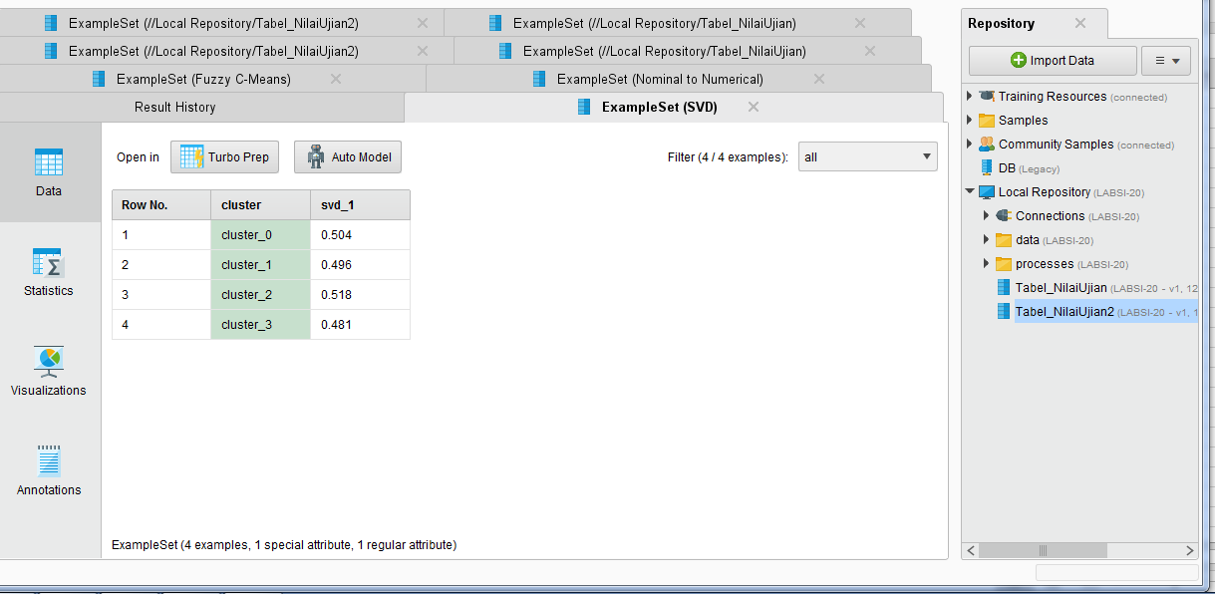

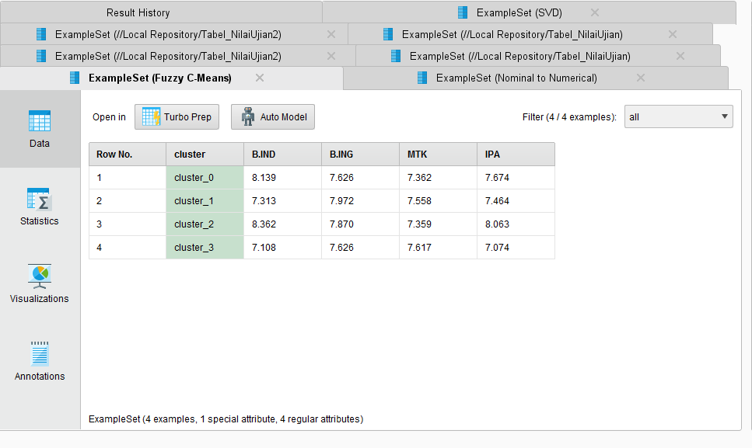

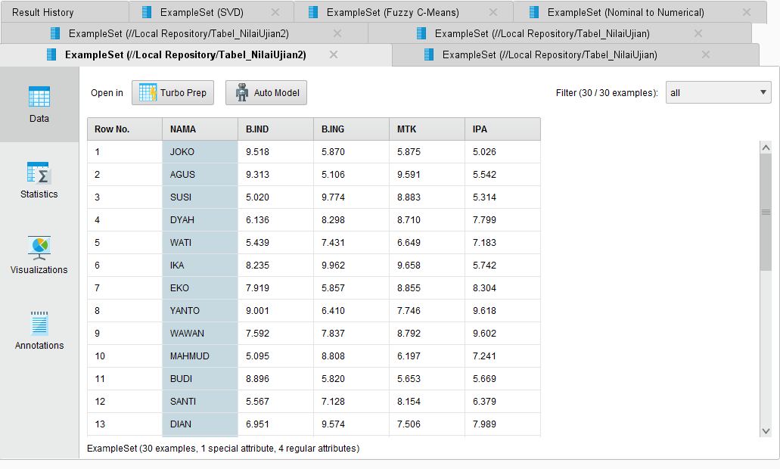

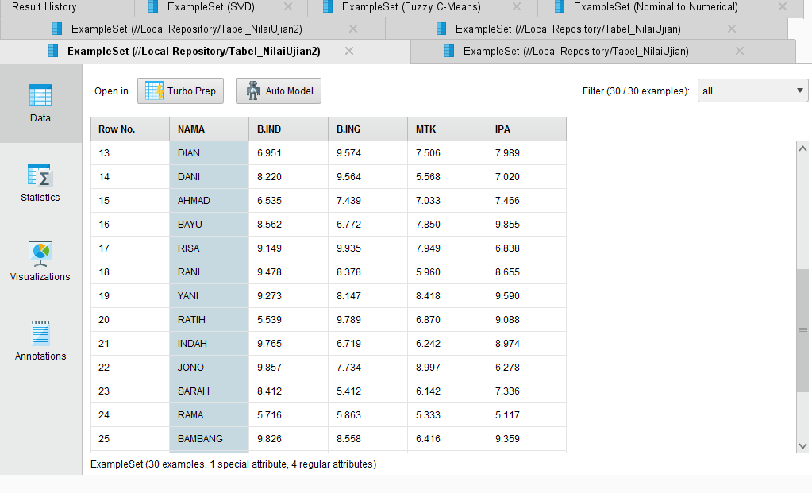

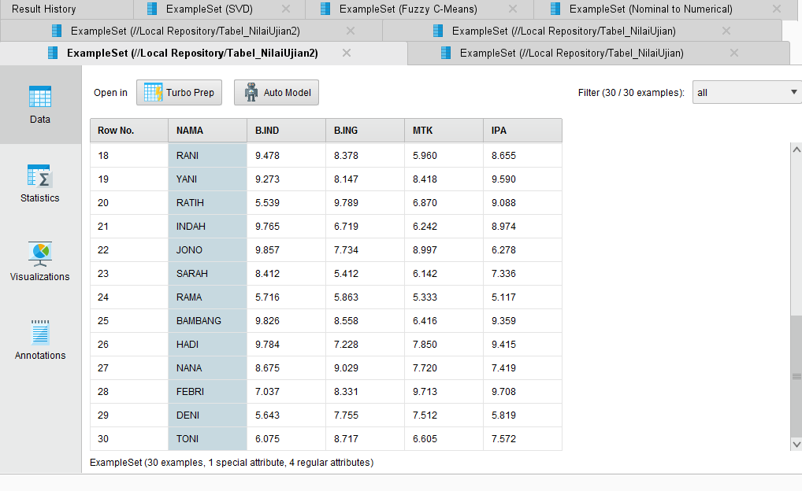

|  |  |  |  |  |  |  |
| --- | --- | --- | --- | --- | --- | --- |
| 1 | JOKO | cluster_0 | 9.518023024748057 | 5.870388173436064 | 5.875433327068088 | 5.0259214738042655 |
| 2 | AGUS | cluster_0 | 9.312911383575463 | 5.105691941635752 | 9.590611066853652 | 5.542047499244985 |
| 7 | EKO | cluster_0 | 7.91894191824761 | 5.857378278314988 | 8.855394190058687 | 8.304428922477467 |
| 11 | BUDI | cluster_0 | 8.895918891888082 | 5.819649940912976 | 5.653244266070605 | 5.66883419059594 |
| 22 | JONO | cluster_0 | 9.856989373476804 | 7.734099772682342 | 8.99698376828043 | 6.278184790798273 |
| 23 | SARAH | cluster_0 | 8.411852103765447 | 5.41225733626511 | 6.141735654768013 | 7.335579930903186 |
| 4 | DYAH | cluster_1 | 6.135720222043807 | 8.29764987276093 | 8.709997683229751 | 7.798752974870291 |
| 6 | IKA | cluster_1 | 8.235071888895764 | 9.961528119651875 | 9.658142983066135 | 5.742467401243226 |
| 13 | DIAN | cluster_1 | 6.950941466230313 | 9.57414338804263 | 7.50574414943029 | 7.988735282469324 |
| 20 | RATIH | cluster_1 | 5.539451758073605 | 9.788572933706115 | 6.870072420754534 | 9.088388634755887 |
| 28 | FEBRI | cluster_1 | 7.037450897290125 | 8.331451319451922 | 9.712772593469225 | 9.708087744501675 |
| 30 | TONI | cluster_1 | 6.075227697001394 | 8.71711837796855 | 6.605303780734015 | 7.571502424064446 |
| 8 | YANTO | cluster_2 | 9.000897144716255 | 6.4097157891733065 | 7.745610704652566 | 9.618050360634776 |
| 9 | WAWAN | cluster_2 | 7.591980443754105 | 7.836859880463724 | 8.791867697663502 | 9.60192699598307 |
| 14 | DANI | cluster_2 | 8.21954384370936 | 9.564138287432701 | 5.567565874582196 | 7.020417928808955 |
| 16 | BAYU | cluster_2 | 8.56156745184421 | 6.772392232608119 | 7.8503121198074535 | 9.854579524516216 |
| 17 | RISA | cluster_2 | 9.149021994302677 | 9.93533877864508 | 7.948934432697313 | 6.838274122687881 |
| 18 | RANI | cluster_2 | 9.478155029831601 | 8.378382834960046 | 5.959533394098115 | 8.654818918675032 |
| 19 | YANI | cluster_2 | 9.272805545388193 | 8.147270301986648 | 8.418364693981845 | 9.589589259248644 |
| 21 | INDAH | cluster_2 | 9.76467928353782 | 6.719100563331181 | 6.242419501458663 | 8.9738133243305 |
| 25 | BAMBANG | cluster_2 | 9.825710646579662 | 8.55836422829348 | 6.41573136170785 | 9.3590230098824 |
| 26 | HADI | cluster_2 | 9.784111319608463 | 7.227842104764737 | 7.849918395665632 | 9.415048288867045 |
| 27 | NANA | cluster_2 | 8.674568573084539 | 9.028510927625256 | 7.719663554598451 | 7.418771922405265 |
| 3 | SUSI | cluster_3 | 5.019884339311924 | 9.774308326202993 | 8.882545103762386 | 5.314181519565988 |
| 5 | WATI | cluster_3 | 5.439282221307561 | 7.43090769012412 | 6.648604563375375 | 7.183183051602225 |
| 10 | MAHMUD | cluster_3 | 5.09539348282351 | 8.808029294450847 | 6.197382665849712 | 7.2414199316094745 |
| 12 | SANTI | cluster_3 | 5.566835375675837 | 7.128286253564578 | 8.154397940835963 | 6.379074984211271 |
| 15 | AHMAD | cluster_3 | 6.534661168322781 | 7.43886984132099 | 7.0330804287946505 | 7.466477196543191 |
| 24 | RAMA | cluster_3 | 5.715637670314622 | 5.8629387664605925 | 5.333327719142451 | 5.11696839988335 |
| 29 | DENI | cluster_3 | 5.643423470158874 | 7.754852258766167 | 7.511911462052854 | 5.818877967477029 |